# Task 1:

2d Game engines:

1. Unity 2D

* .25 Eu monthly subscription fee
* .it uses C# as programming language
* .it has a lot of documentation and tutorials.
* .it’s really customable.
* It can be used to make games for different platforms

1. Unreal Engine

* .it’s really portable
* .it’s open source
* .it uses global illumination instead of precomputed illumination
* .compatible with oculus rift
* .uses unreal script, its own programming language

1. Construct 3

* .it supports multiple programming languages
* .it exports the games as HTML5
* Open source
* .it’s compatible with console the wii U/Xbox One
* .it’s available in almost every platform.

1. RPG Maker

* .user friendly
* .it has already premade sprites
* .it’s not monthly subscription based
* .it’s not necessary to know how to code to use the program

3d game engines:

1. Cryengine:

* It uses C++ as programming language
* It supports cross platform
* It uses polybump technology for ease to model
* It has an advance modular AI System
* It facilitates scripting

1. Source2:

* It’s constantly being updated
* It uses Source SDK
* It has a function called Source Film Maker
* It uses it’s own servers, instead of requiring a client
* It’s compatible with Vulcan Graphical API

1. A4 Engine:

* it support Direct 3D
* it supports OPEN GL
* it supports NVIDIA’S PhysX
* Open Source
* It supports NVIDIA’S 3D VISION

1. Frostbite:

* Crossplatform
* It uses mainly c++ as programming language
* It uses Mantle as Rendering API
* Supports VR
* It support ingame mass changes

# Task 2

Programing languages:

1. C++

* It is a compiled language
* It has a large library of it’s own

1. JavaScript

* It’s really flexible
* It uses curly brackets syntax

1. Java

* It can run anywhere
* It is compiled in to Bytecode

1. Unreal Script

* It supports visual scripting
* It doesn’t use multiple inheritance

1. Python

* It’s available for almost every operating system
* It’s easy to read

1. TypeScript

* It support javascript libraries
* It supports node.js

1. C#

* It is an automatic garbage collector
* It’s really similar to c and c++

# Task3

A)

In the multimedia world compression is used a lot for delivering images, sounds, videos, etc.

It is important to use compression so that the file doesn’t occupy a lot of storage.

There are two forms of compression lossy and lossless:

Lossy works by compressing an image and not losing any data when decompressed.

Lossless works by compressing more than lossy, but losing some data by doing so

B)

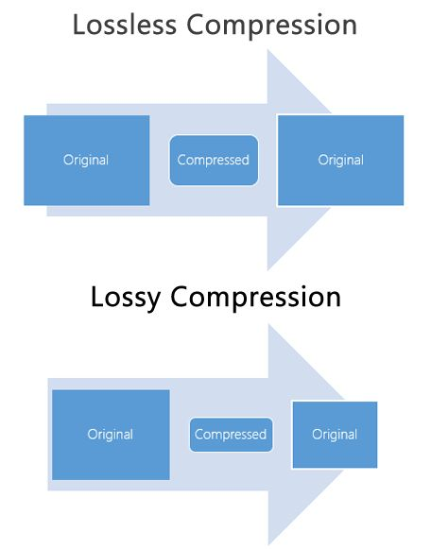

Compression works by deconstructing the original image and recreating it.